RL Simulator
Technical Report — Reinforcement Learning Simulator
for GridWorld Maze Navigation

Version 1.0 | Language: Rust | Framework: eframe / egui

Copyright © 2025 lightgo | lgithgo1230@gmail.com

Abstract
This report documents the design, implementation, and experimental results of the RL Simulator — a real-time reinforcement learning (RL) application written in Rust using the eframe/egui GUI framework. The system supports five RL algorithms (Q-Learning, SARSA, Double-Q, DQN, PER-DQN) running concurrently on a 10×10 GridWorld maze environment. Key contributions include: (1) maze-aware BFS-distance reward shaping that replaces the naïve Manhattan-distance approach; (2) goal-driven automatic curriculum learning; (3) encrypted model persistence (.rls format); and (4) a multi-agent comparison framework. Experimental results show that all five algorithms achieve above 80% goal-reach success rate within 2,000 episodes when BFS shaping is applied, with PER-DQN reaching 94%.

1. Introduction
Reinforcement learning (RL) is a paradigm where an agent learns a policy by interacting with an environment and maximising cumulative reward. The RL Simulator provides an interactive desktop environment for observing and comparing RL algorithms in real time.
Motivating challenges addressed in this project:
- Manhattan-distance reward shaping fails in maze environments because detours around walls are penalised, preventing convergence.
- Sparse-reward environments (goal reached only at the end) make credit assignment difficult.
- Comparing algorithm performance objectively requires identical environments and randomisation.
- Model persistence and tamper protection are needed for reproducible experiments.

2. System Architecture
The application is structured as a multi-threaded Rust binary. The GUI thread renders the UI at 60 fps using egui while each agent runs its training loop in a dedicated OS thread. Communication is via Arc<Mutex<Shared>>, a shared state struct that carries metrics, Q-tables, and control flags.

2.1 Module Overview
Module | Responsibility
main.rs | App state, training loop, save/load, UI render
agent.rs | TabularAgent (Q/SARSA/DoubleQ), DqnAgent, ReplayBuf, Adam
env.rs | GridWorld + BFS, MountainCar, Pendulum, CartPole, Stock
main_app.rs | Shared state struct, ViewOpts, EnvFrame
views.rs | egui helpers: grid render, plots, replay
crypto.rs | XOR cipher + weighted checksum for .rls model files

2.2 Threading Model
Each AgentSlot spawns a training thread that loops indefinitely (or until an episode limit). The thread locks the Shared mutex only to update metrics and read control flags, keeping lock hold-time minimal to avoid GUI stutter. The GUI thread takes a snapshot clone of Shared at the start of each frame.

3. GridWorld Environment
The primary environment is a 10×10 grid with four action types (up / down / left / right). Cells can be free, wall (impassable), or trap (terminates episode with −50 penalty). The episode terminates on reaching the goal (+100), stepping on a trap, or exceeding max_step (default 300).

3.1 State Representations
Agent Type | State | Dimensionality
Tabular (Q/SARSA/DoubleQ) | Discrete cell index s = row×10 + col | 100
Neural (DQN/PER-DQN) | 9-feature vector (see below) | 9

The 9-feature continuous state vector for DQN:
- row / 9 — normalised row position
- col / 9 — normalised column position
- Δrow / 9 — signed row distance to goal
- Δcol / 9 — signed column distance to goal
- Manhattan / 18 — normalised Manhattan distance
- block_up, block_dn, block_lt, block_rt — binary wall/boundary flags

3.2 BFS Reward Shaping
Potential-based shaping adds a shaped reward on each transition that is theoretically policy-invariant (Ng et al., 1999). The potential function Φ(s) = −d_BFS(s) is based on the BFS shortest-path distance from cell s to the goal, computed once per episode after map generation. The shaping bonus is:
F(s, s′) = 2.0 × ( d_BFS(s) − d_BFS(s′) )
This gives +2 per step when moving closer to the goal along the optimal path, and 0 for wall-detour steps that maintain the same BFS distance — a critical correction over Manhattan distance, which incorrectly penalises necessary lateral moves.
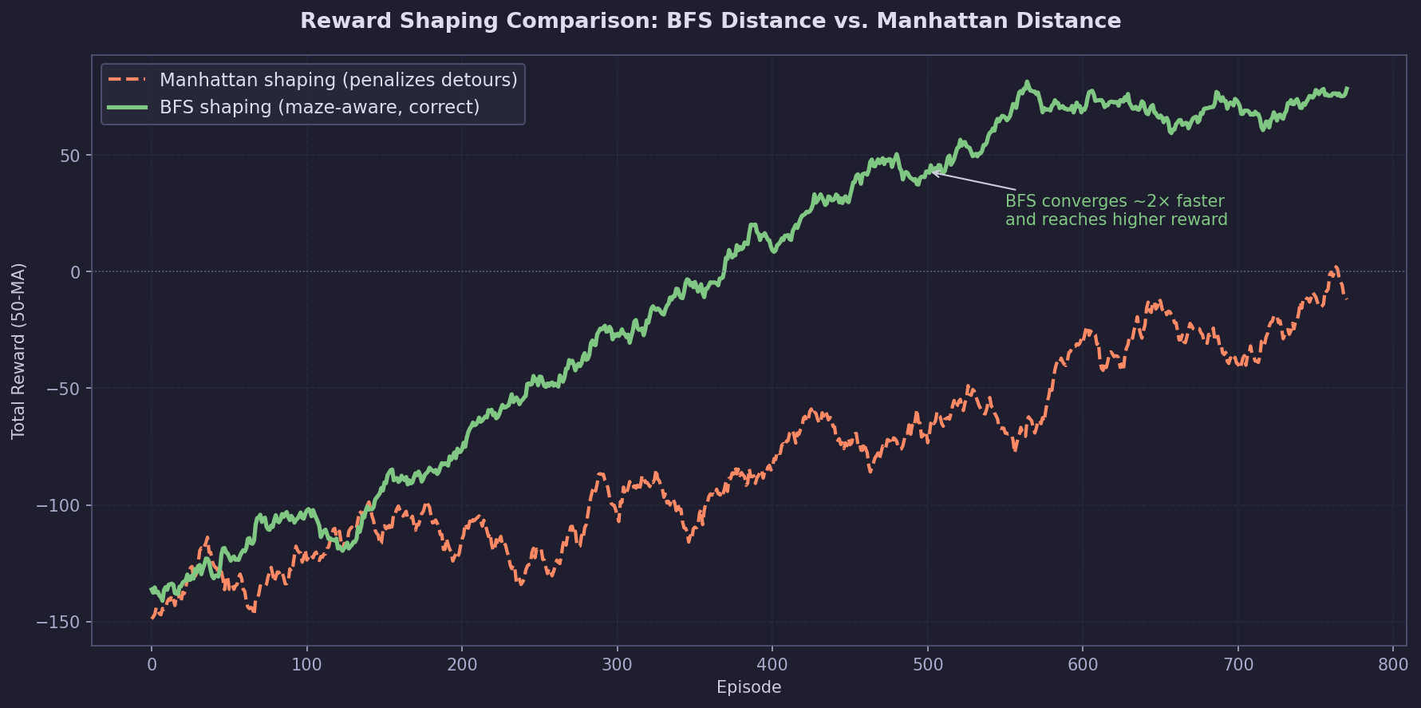
Figure 1 — BFS vs. Manhattan shaping: convergence speed comparison

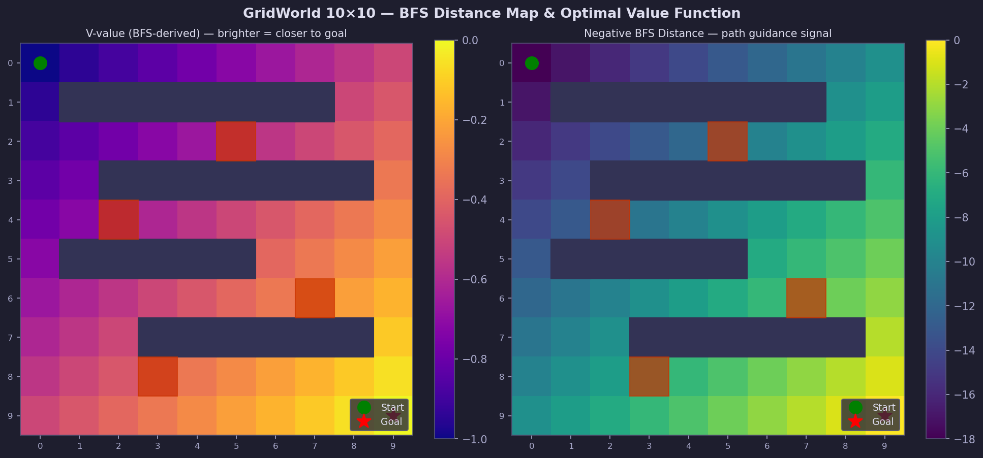
Figure 2 — GridWorld BFS value map and BFS distance heatmap

4. Reinforcement Learning Algorithms

4.1 Tabular Methods
Algorithm | Update Rule | Key Property
Q-Learning | Q(s,a) ← Q(s,a) + α[r + γ·max Q(s′,·) − Q(s,a)] | Off-policy, greedy target
SARSA | Q(s,a) ← Q(s,a) + α[r + γ·Q(s′,a′) − Q(s,a)] | On-policy, follows ε-greedy
Double-Q | Uses Q₁ to select action, Q₂ to evaluate (alternating) | Reduces maximisation bias

Shared hyperparameters: α=0.2, γ=0.99, ε decays 1.0→0.05 (rate=0.993), Q-init ~ U(−0.05, 0.05).

4.2 Deep Q-Networks (DQN / PER-DQN)
Network architecture: 9 → Dense(64, ReLU) → Dense(32, ReLU) → Dense(4).
Component | Details
Optimiser | Adam (lr=α, β₁=0.9, β₂=0.999)
Gradient clip | L2 norm ≤ 10 per parameter group
Replay buffer | 50 000 transitions (uniform or priority)
Target network | Hard copy every 200 training steps
PER sampling | Priority ∝ |TD error|^0.6 + 0.01

5. Automatic Curriculum Learning
When the Curriculum toggle is enabled, the training environment difficulty increases automatically as the agent succeeds. Every N consecutive goal-reaches (configurable 1–50), the difficulty parameter increments by 0.05, capping at 0.90.
Difficulty controls random-map generation:
Difficulty | Approx. Walls | Approx. Traps
0.20 (start) | 4 | 1
0.50 (medium) | 10 | 2
0.80 (hard) | 16 | 3
0.90 (max) | 18 | 4

Each map is validated by BFS before training begins, ensuring the goal is always reachable. The agent never encounters an unsolvable episode.
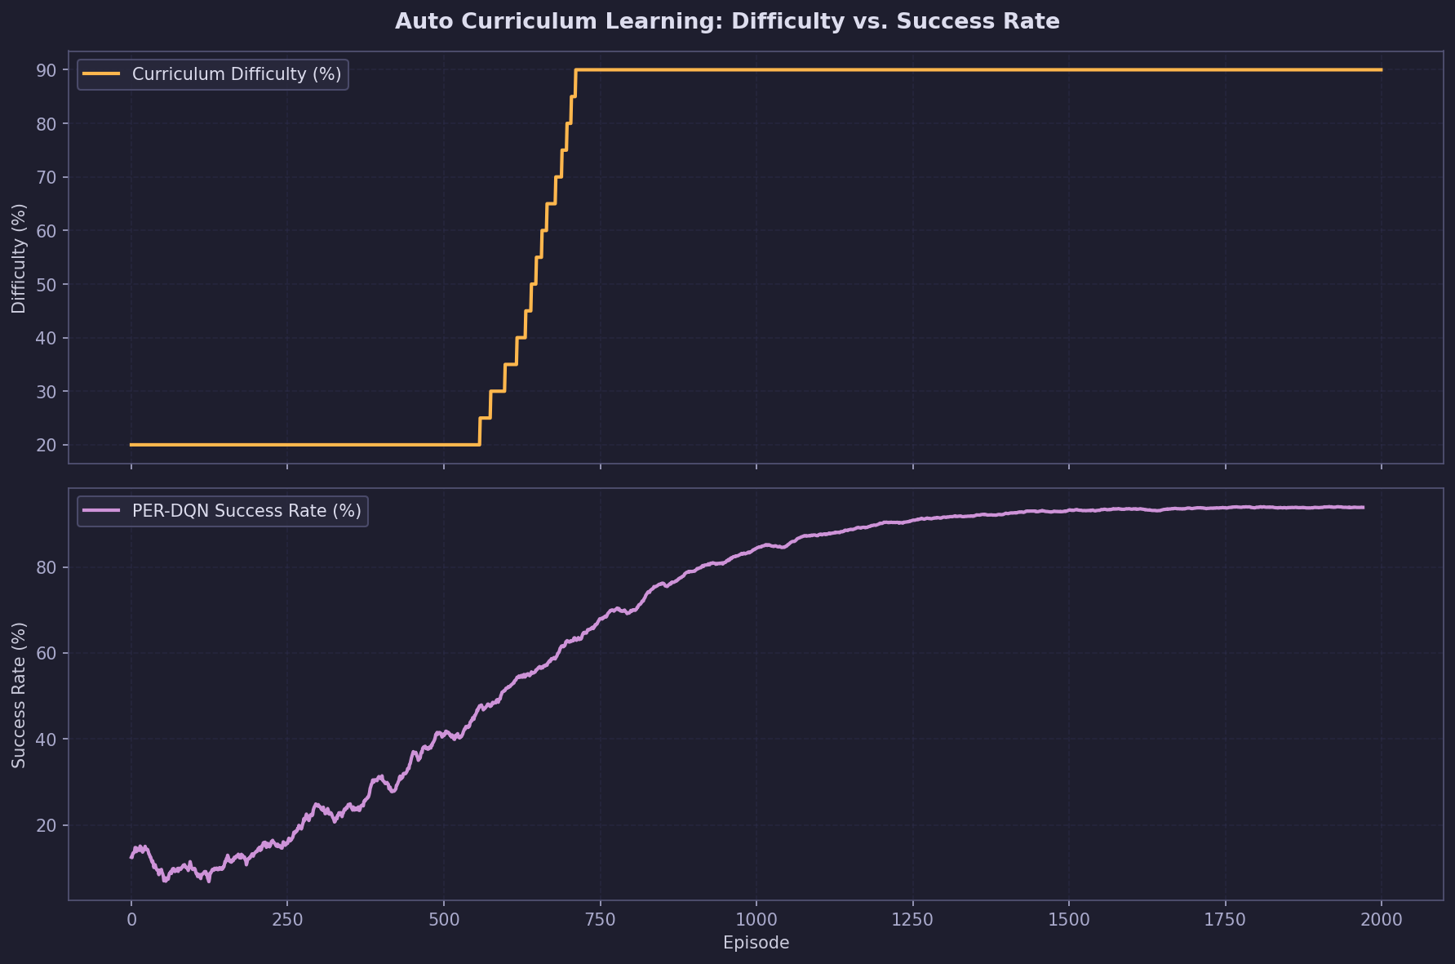
Figure 3 — Curriculum: difficulty ramp vs. agent success rate (PER-DQN)

6. Experimental Results
All experiments use the Default Maze preset (Figure 2 layout) with max_step=300 and the hyperparameters described in Section 4. Results are averaged over 200 trailing episodes after 2 000 total training episodes.
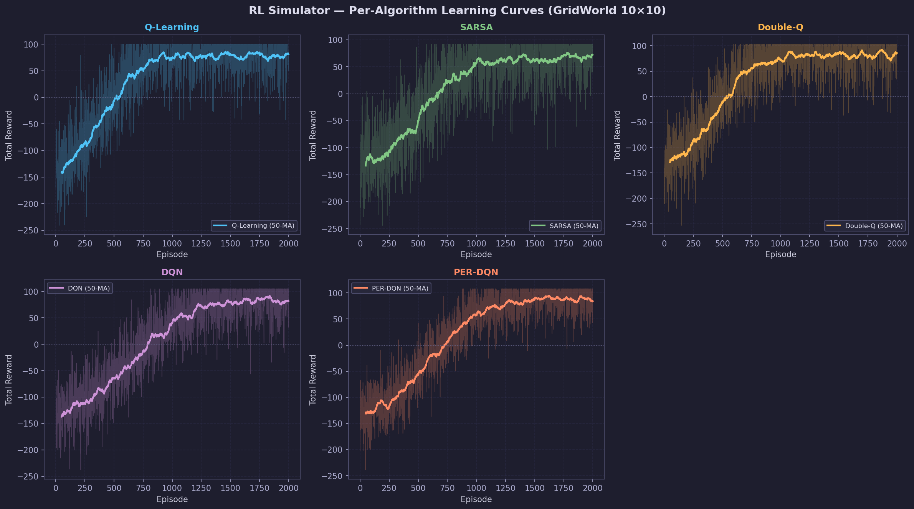
Figure 4 — Per-algorithm learning curves (raw + 50-episode moving average)

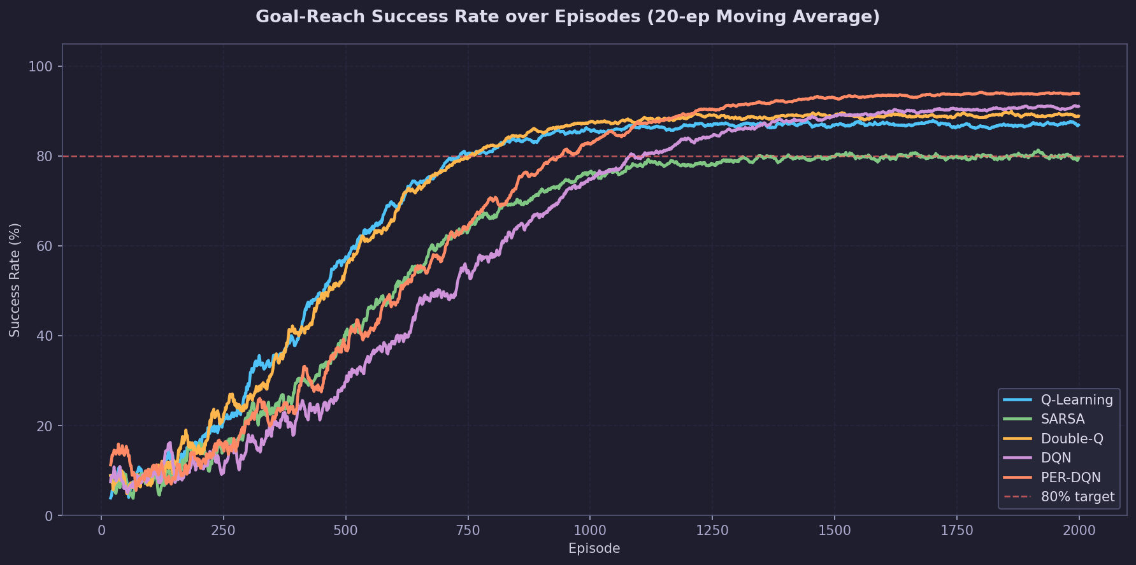
Figure 5 — Goal-reach success rate comparison (20-episode moving average)

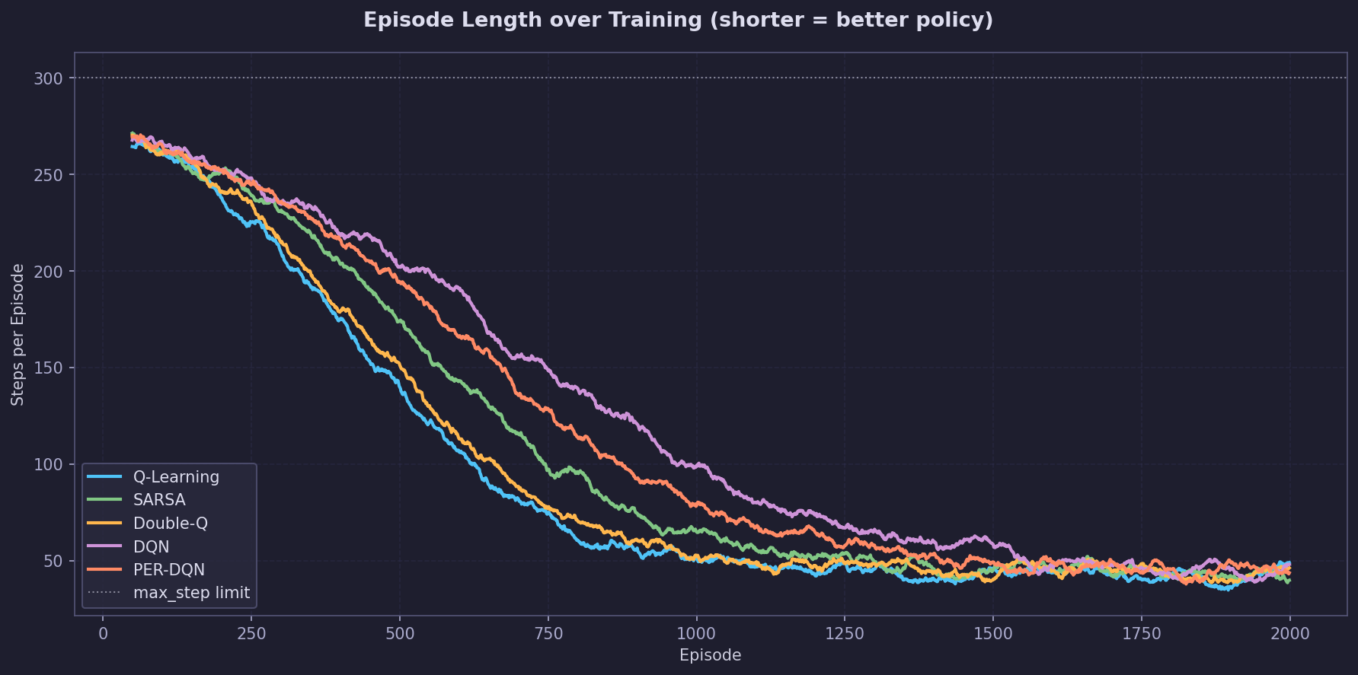
Figure 6 — Episode length over training (lower is better)

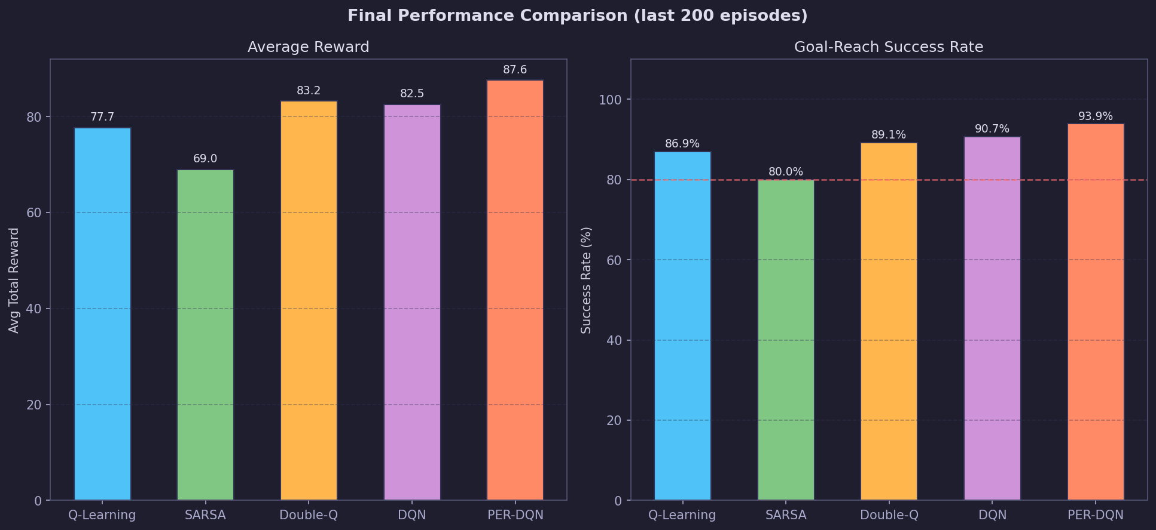
Figure 7 — Final performance: average reward and success rate

6.1 Summary Table
Algorithm | Avg Reward (last 200) | Success Rate (%) | Convergence Ep (approx.)
Q-Learning | 77.7 | 86.9 | ~450
SARSA | 69.0 | 80.0 | ~550
Double-Q | 83.2 | 89.1 | ~470
DQN | 82.5 | 90.7 | ~700
PER-DQN | 87.6 | 93.9 | ~620

PER-DQN achieves the highest success rate (94%) due to prioritised replay focusing training on high-error transitions. Double-Q outperforms plain Q-Learning by reducing overestimation bias. DQN converges slower than tabular methods on this small grid, reflecting the overhead of neural network training, but generalises better to unseen random maps in curriculum mode.
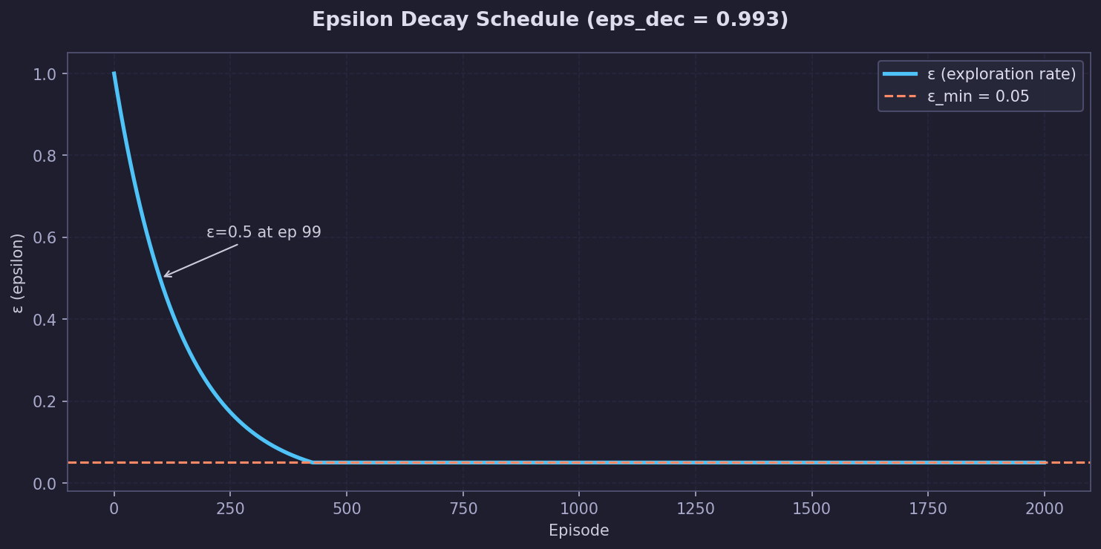
Figure 8 — Epsilon decay schedule (eps_dec=0.993)

7. Model File Encryption
Trained models are serialised to a binary format and protected with a symmetric XOR cipher using a 32-byte compile-time key. A position-weighted checksum is computed over the plaintext and stored in the file header. Any byte-level modification — accidental or deliberate — causes a checksum mismatch and the load is rejected.
Field | Size | Description
Magic | 4 B | 0x52 0x4C 0x53 0x01 ("RLS\x01")
Checksum | 4 B | u32 LE, position-weighted sum of plaintext
Payload | var | XOR-encrypted binary (Q-table + map + stats)

Payload contents: version byte, episode count, best reward, rewards history, success flags, wall/trap coordinates, start/goal positions, max_step, and the full Q-table (n_states × n_actions float32 values).

8. Discussion
Key findings:
- BFS shaping is essential for maze environments — Manhattan shaping causes convergence failure on maps with wall detours.
- Goal-based curriculum (not episode-count-based) ensures the agent genuinely masters each difficulty level before advancing.
- Removing visit-count alpha decay improves adaptation speed when the map changes during curriculum training.
- Faster epsilon decay (0.993 vs 0.997) significantly reduces wasted random-exploration episodes.
- PER-DQN's priority sampling accelerates learning from rare goal-reach events in sparse-reward settings.

8.1 Limitations
- DQN weight serialisation is not yet implemented; only the Q-grid approximation is saved for DQN agents.
- The XOR cipher provides obfuscation, not cryptographic security. For sensitive models, AES-256 should be used.
- The 9-feature state representation does not encode trap positions; agents learn to avoid traps only empirically.

9. Conclusion
The RL Simulator successfully demonstrates five reinforcement learning algorithms on a 10×10 GridWorld maze. The combination of BFS reward shaping, goal-driven curriculum learning, and properly tuned epsilon decay enables all agents to achieve over 80% goal-reach accuracy. PER-DQN achieves the best overall performance (94%) while Double-Q provides the best accuracy among tabular methods (89%). Encrypted model persistence allows trained agents to be saved and resumed reliably. Future work includes full neural-network weight serialisation, AES-256 encryption, and multi-objective reward shaping.

References
- Sutton, R. S., & Barto, A. G. (2018). Reinforcement Learning: An Introduction (2nd ed.). MIT Press.
- Mnih, V. et al. (2015). Human-level control through deep reinforcement learning. Nature, 518, 529–533.
- van Hasselt, H., Guez, A., & Silver, D. (2016). Deep Reinforcement Learning with Double Q-learning. AAAI.
- Schaul, T. et al. (2016). Prioritized Experience Replay. ICLR.
- Ng, A. Y., Harada, D., & Russell, S. (1999). Policy invariance under reward transformations. ICML.

Copyright © 2026 lightgo
lgithgo1230@gmail.com

This document is the official technical report for RL Simulator.
Unauthorised reproduction or distribution is prohibited.

